RMSOptimizer :

Average Loss= 5.381041,

Average Accuracy= 0.10%

learning_rate = 0.001  
training_iters = 100  
display_step = 10  
n_input = 3

n_hidden = 1024

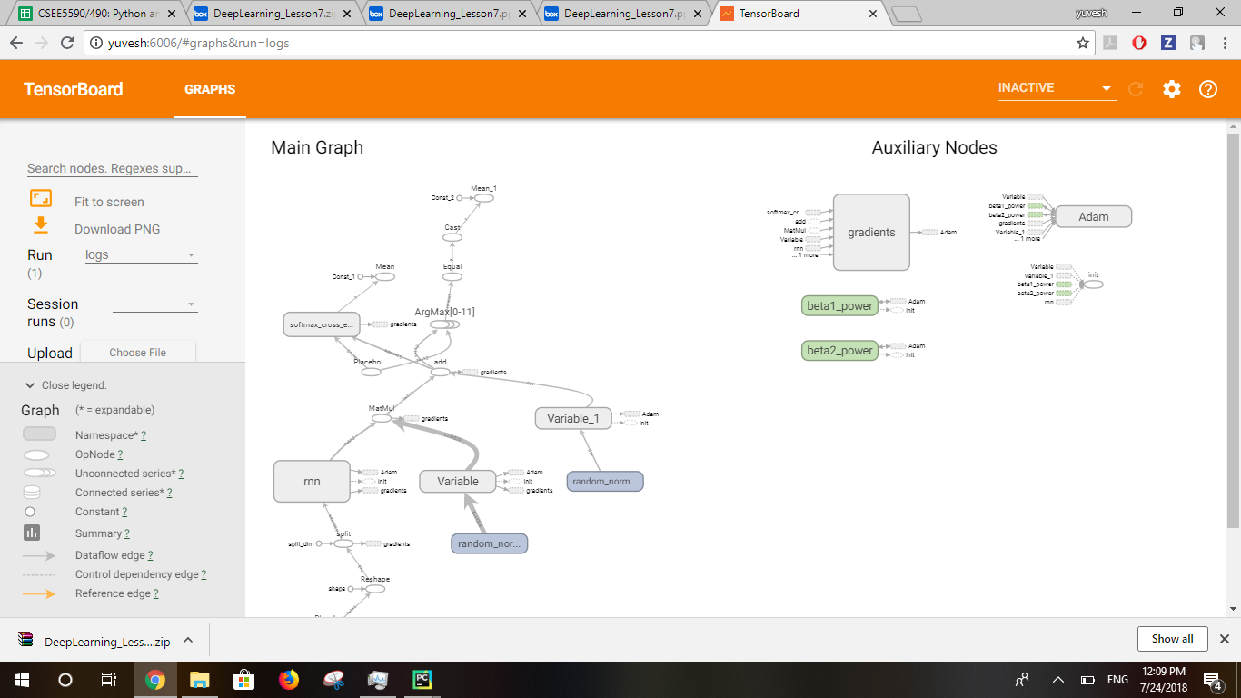

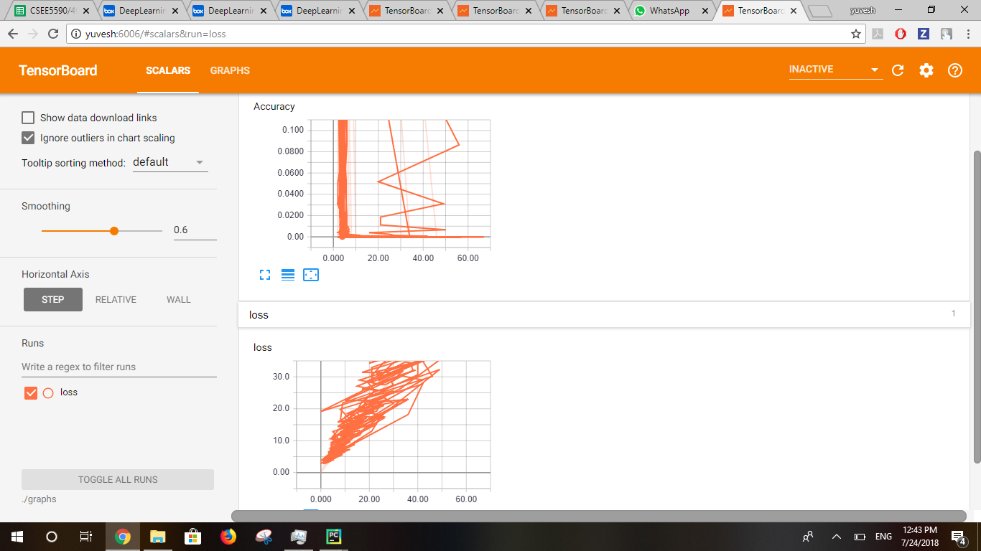

Adam optimizer:

Average Loss= 5.527556,

Average Accuracy= 0.00%

learning_rate = 0.001  
training_iters = 100  
display_step = 10  
n_input = 3

n_hidden = 1024

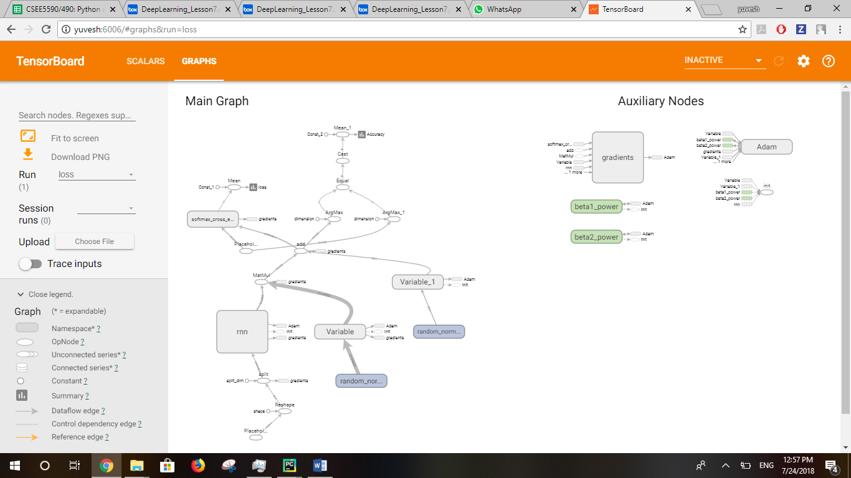

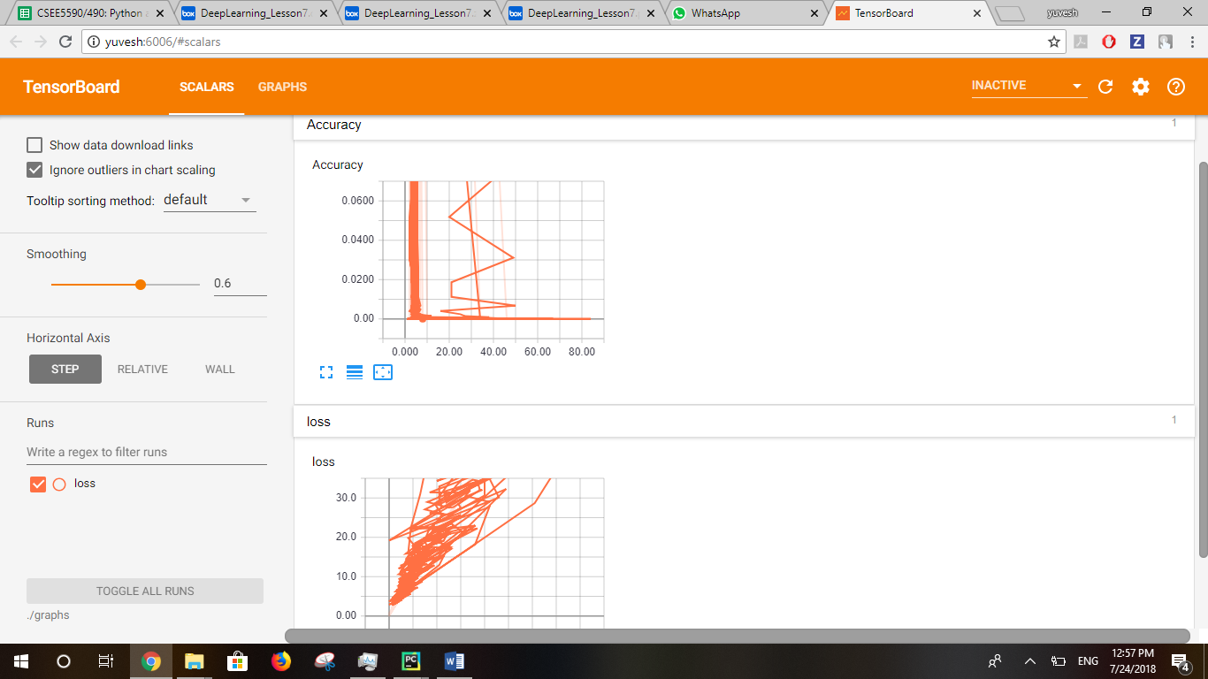

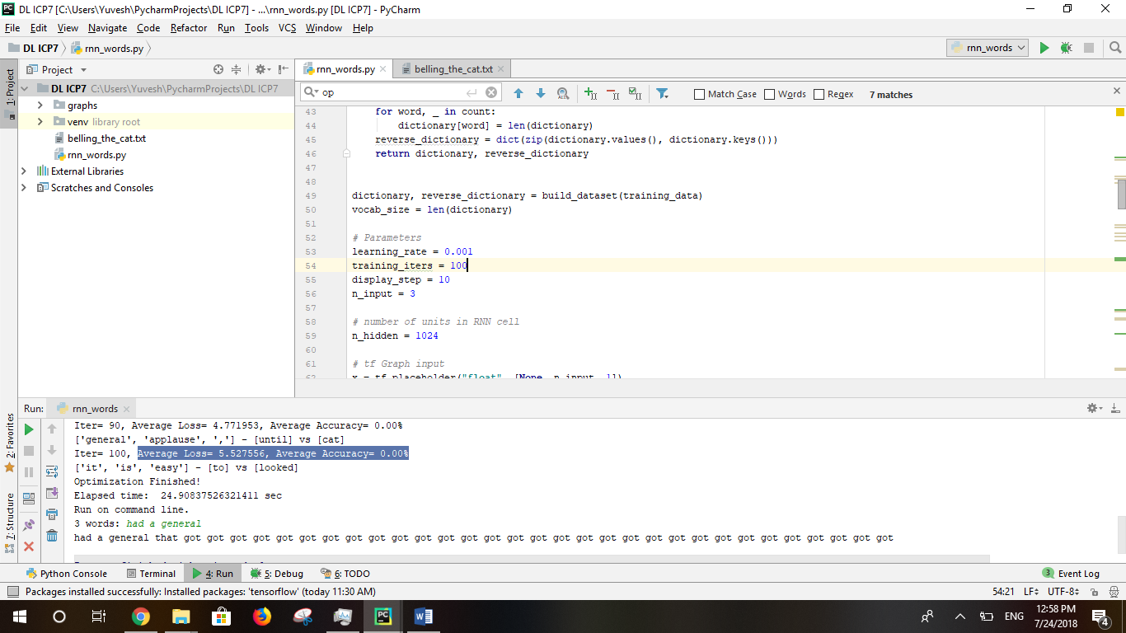

Adam optimizer:

Average Loss= 242.344316,

Average Accuracy= 1.00%

learning_rate = 0.1  
training_iters = 1000  
display_step = 100  
n_input = 4

n_hidden = 1024

